Adding professional skills to your resume

Technical skills are crucial when building a solid resume. They demonstrate to employers that you have the professional skills necessary to successfully perform the job. Think of professional skills as your toolbox: How you list each skill on your resume is how you demonstrate to employers that you are capable of using those tools.

**Common professional skills for entry-level data analysts**

It takes lots of skills to be a successful data analyst, and these are some common ones that employers seek out when hiring for data analyst jobs:

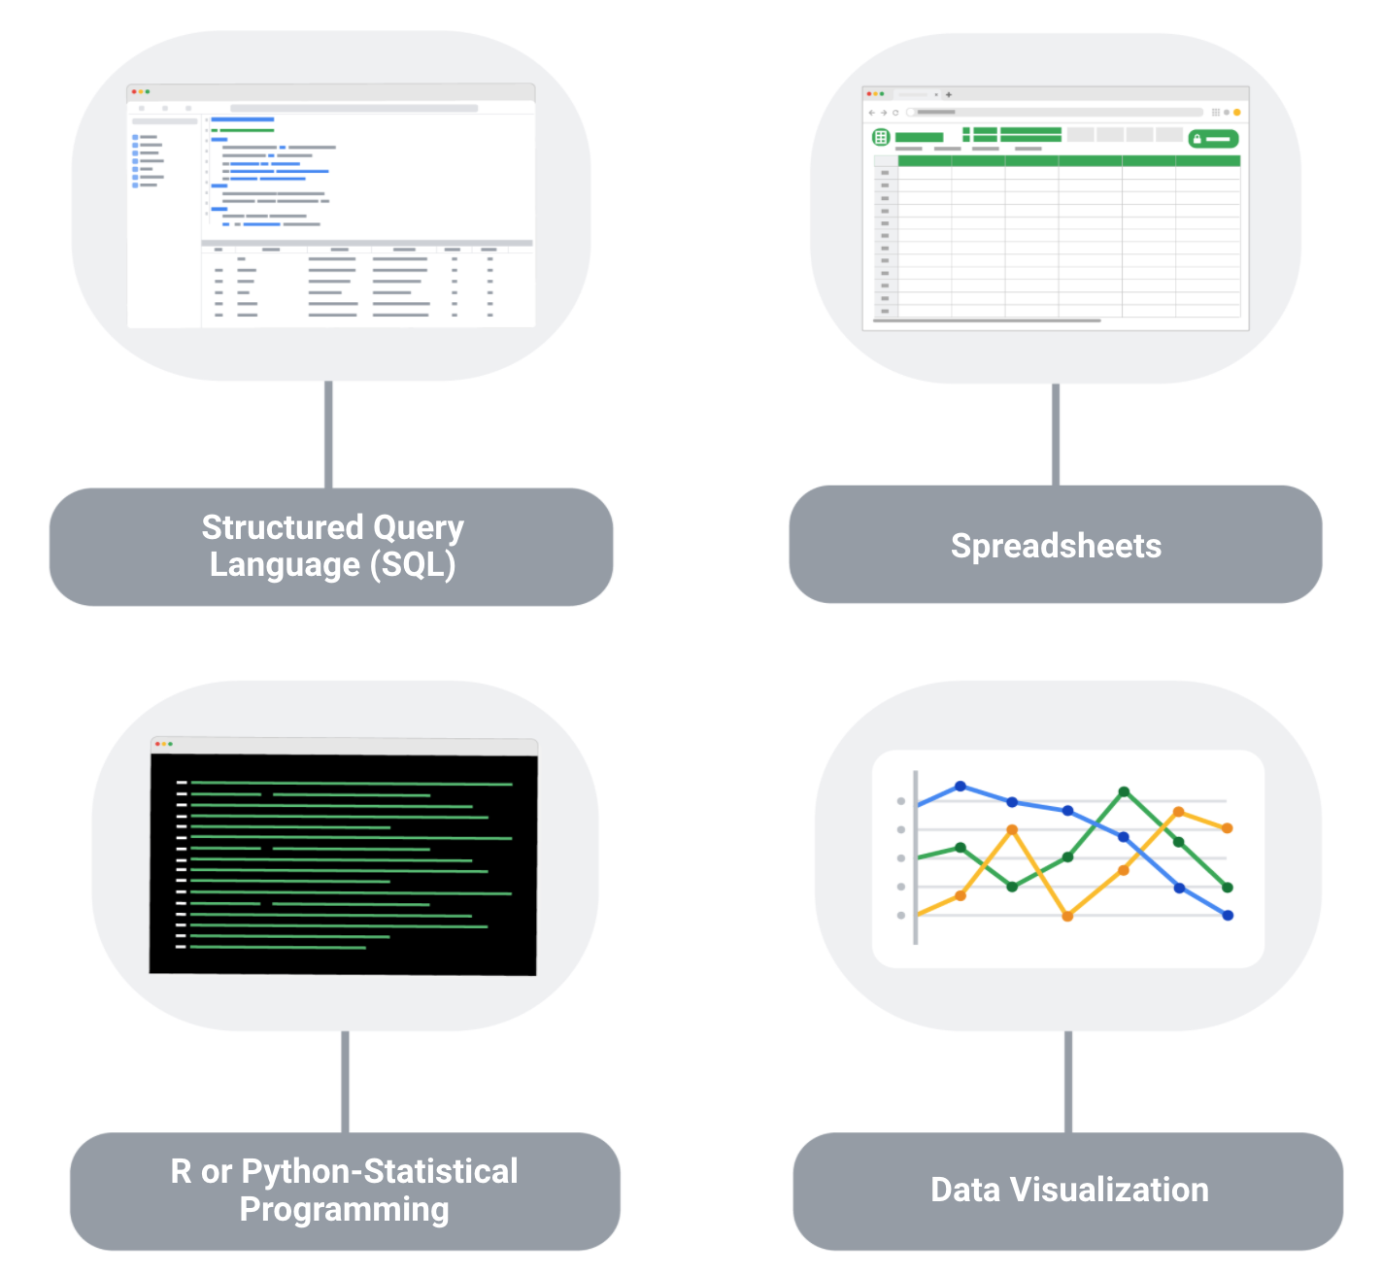

**1. Structured Query Language (SQL):** SQL is considered a basic skill that is pivotal to any entry-level data analyst position. SQL helps you communicate with databases, and more specifically, it is designed to help you retrieve information from databases. Every month, thousands of data analyst jobs posted require SQL, and knowing how to use SQL remains one of the most common job functions of a data analyst.

**2. Spreadsheets:** Although SQL is popular, 62% of companies still prefer to use spreadsheets for their data insights. When getting your first job as a data analyst, the first version of your database might be in spreadsheet form, which is still a powerful tool for reporting or even presenting data sets. So, it is important for you to be familiar with using spreadsheets for your data insights.

**3. Data visualization tools:** Data visualization tools help to simplify complex data and enable the data to be visually understood. After gathering and analyzing data, data analysts are tasked with presenting their findings and making that information simple to grasp. Common tools that are used in data analysis include Tableau, Microstrategy, Data Studio, Looker, Datarama, Microsoft Power BI, and many more. Among these, Tableau is best known for its ease of use, so it is a must-have for beginner data analysts. Also, studies show that data analysis jobs requiring Tableau are expected to grow about 34.9% over the next decade.

**4**. **R or Python programming:** Since only less than a third of entry-level data analyst positions require knowledge of Python or R, you don’t need to be proficient in programming languages as an entry-level data analyst. But, R or Python are great additions to have as you become more advanced in your career.

**Key takeaway**

As a data analyst, you are often asked to collect and analyze data with a specific purpose in mind. Knowing which platform and language to use helps you analyze the data to decipher which information is important, to probe for any anomalies, prepare questions, assess risks, and so much more.